# Intermediate Spreadsheets.

1. [1.] Rounding numbers [Yuvarlama sayıları]

When performing calculations, you want your numbers to be as accurate as possible. [Hesaplamalar yaparken, sayılarınızın mümkün olduğunca doğru olmasını istersiniz.] However, reading numbers with eight decimal places is tiresome, so when you come to report numbers, it is often useful to round them first. [Bununla birlikte, sekiz ondalık basamaklı sayıları okumak yorucudur, bu nedenle sayıları rapor etmeye geldiğinizde, genellikle önce onları yuvarlamak yararlıdır.]

## 2. [2.] Rounding [yuvarlama]

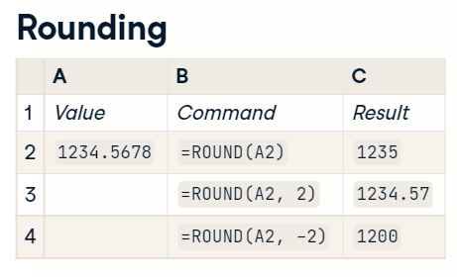

The ROUND() function, as you might expect, rounds numbers. [ROUND() işlevi, tahmin edebileceğiniz gibi sayıları yuvarlar.] If you give it one argument, it will round the input to the nearest whole number, as shown by the first command here. [Bir argüman verirseniz, buradaki ilk komutta gösterildiği gibi girişi en yakın tam sayıya yuvarlayacaktır.] You can also specify the number of decimal places to round the number to. [Sayının yuvarlanacağı ondalık basamak sayısını da belirtebilirsiniz.] In the next row, you can see that specifying two decimal places rounds the number to the nearest hundredth. [Sonraki satırda, iki ondalık basamak belirtmenin sayıyı en yakın yüzlüğe yuvarladığını görebilirsiniz.] The final row shows that specifying negative two decimal places rounds the number to the nearest hundred. [Son satır, negatif iki ondalık basamak belirtmenin sayıyı en yakın yüzlüğe yuvarladığını gösterir.]

## 3. [3.] Ceiling and floor (1) [Tavan ve zemin (1)]

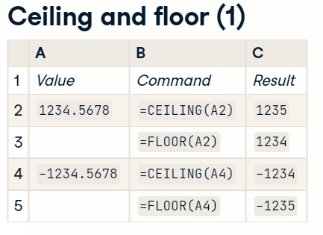

ROUND() always rounds toward the nearest whole number, but sometimes you may wish to always round upwards or always round downwards. [ROUND() her zaman en yakın tam sayıya yuvarlar, ancak bazen her zaman yukarı veya her zaman aşağı yuvarlamak isteyebilirsiniz.] This is accomplished through the CEILING() and FLOOR() functions. [Bu, CEILING() ve FLOOR() işlevleri aracılığıyla gerçekleştirilir.] CEILING() rounds to the nearest whole number towards infinity, and FLOOR() rounds towards negative infinity. [CEILING() sonsuza doğru en yakın tam sayıya yuvarlar ve FLOOR() negatif sonsuza doğru yuvarlar.]

## 4. [4.] Ceiling and floor (2) [Tavan ve zemin (2)]

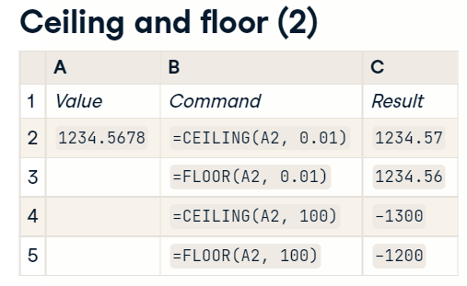

CEILING() and FLOOR() also provide ways to round to fractions of numbers, but the syntax is different to ROUND(). [CEILING() ve FLOOR() ayrıca sayıların kesirlerine yuvarlamanın yollarını sağlar, ancak sözdizimi ROUND()'dan farklıdır.] In order to round up or down to the nearest hundredth, rather than specifying two decimal places, you would pass one hundredth directly. [En yakın yüzlüğe yuvarlamak için iki ondalık basamak belirtmek yerine doğrudan yüzüncüyü geçersiniz.]

## 5. [5.] Summary [özet]

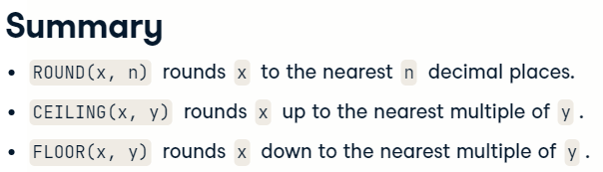

You've just seen three functions for rounding numbers. [Az önce sayıları yuvarlamak için üç işlev gördünüz.] ROUND() will round up or down to the nearest value; CEILING() always rounds up towards infinity, and FLOOR() always rounds round toward negative infinity. [ROUND() en yakın değere yukarı veya aşağı yuvarlar; CEILING() her zaman sonsuza doğru yuvarlar ve FLOOR() her zaman negatif sonsuza doğru yuvarlar.]

## 6. [6.] Let's get rounding! [Yuvarlamaya başlayalım!]

Alright! [Tamam!] Let's try some rounding! [Biraz yuvarlama deneyelim!]

#### Round and round

Often, numbers are easier to read if you limit how precisely they are written. For example, 75 is easier to read than 74.9729526456456.

[**ROUND()**](https://support.google.com/docs/answer/3093440) lets you round numbers to a specified number of decimal places.

* ROUND(A1) rounds the number in cell A1 to the nearest whole number.
* ROUND(A1, 3) rounds it to three decimal places - or, in other words, to the nearest thousand**th**.
* ROUND(A1, -3) rounds it to the nearest thousand.

##### Instructions

* In column H, round the aphelion to the nearest whole number.
* In column I, round the perihelion to one decimal place (to the nearest tenth)
* In column J, round the upper bound of the size to the nearest hundred.

#### (2) From floor to ceiling

Sometimes you always want to round a value down (towards negative infinity), or always round upwards (towards infinity). You can do this using

* [**FLOOR()**](https://support.google.com/docs/answer/3093487), which rounds down, and
* [**CEILING()**](https://support.google.com/docs/answer/3093471), which round up.

Both functions take a second argument that specifies the multiple to round to. For example, FLOOR(A1, 0.01) rounds the number in cell A1 down to the next lowest hundredth. If this argument is omitted, it rounds down to the nearest whole number.

##### Instructions

* In column H, round the aphelion down to the nearest whole number.
* In column I, round the perihelion up to the next tenth.

#### Rounding negative numbers

FLOOR() and CEILING() will round negative numbers towards or away from negative infinity. That is, FLOOR(-1.5) is -2 and CEILING(-1.5) is -1.

Sometimes you may wish to round them towards or away from zero.

Google Sheets has two related functions called FLOOR.MATH() and CEILING.MATH(). When given one or two arguments, they behave in the same way as FLOOR() and CEILING() respectively. However, you can pass a third argument that determined the direction of the rounding: passing a positive number (for example, 1) to a third argument to make them round in the positive direction - towards zero.

That is, FLOOR.MATH(-1.57, 0.1, 1) is -1.5 and CEILING.MATH(-1.57, 0.1, 1) is -1.6.

##### Instructions

* In column H, take the perihelion and subtract the aphelion (column G minus column F) to create some negative numbers.
* In column I, use FLOOR.MATH() to round those differences to the next hundredth (0.01) towards zero.
* In column J, use CEILING.MATH() to round those differences to the next tenth (0.1) away from zero.

`FLOOR.MATH(x, , 1)` is equivalent to `SIGN(x) * FLOOR(ABS(x))` and `CEILING.MATH(x, , 1)` is equivalent to `SIGN(x) * CEILING(ABS(x))`.